Profile Coffee Barista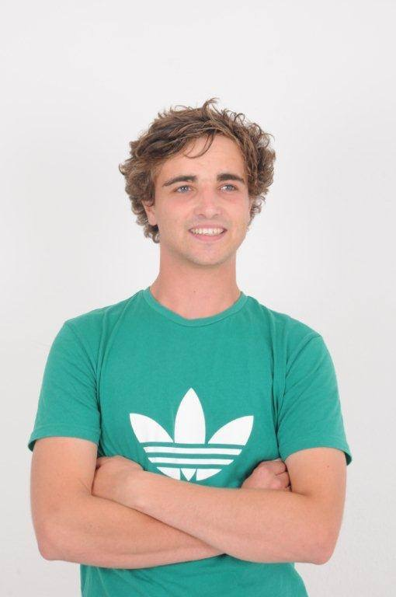

Experience Modelling Work

Model work for commercials and photo shoots.

April 2010 - August 2012

T-shirt Business

Created and sold original design T-shirts both personally and stocked in store.

2011

Organic Market

Grew and sold organic vegetables locally.

Ivan Copeland

24 De Stadler Ave

Capri

M 079 922 9061

ivan.copeland2018@gmail.com

2013

Freelance Work

Created animated videos for Eco Safety (Health & Safety Business) for a 3 month period.

2013

Delivery Extreme

Food delivery.

November 2013 - March 2014

Espresson.Kom

Barista for local coffee shop in Kommetjie.

January 2015 - April 2015.

Education *Primary School Education:*

Mc Gregor Waldorf (2002 - 2005)

Imhoff Waldorf (2005 - 2007)

*Secondary School Education:*

Constantia Waldorf (2007 - 2009)

Valley Tutor Centre (2010 - 2013)

Highest grade passed: IGCSE as well as some AS Levels, currently studying towards the remaining needed for Tertiary Education.   
Subjects passed:

English (IGCSE & AS Level)

Physics (IGCSE & AS Level)

Mathematics (IGCSE)

Business Studies (IGCSE)

Information & Communication Technology (IGCSE)

Biology (IGCSE)

Physics (IGCSE)

________________________________________________________________________________

Skills I like working with people, I am excellent at Maths and good with children as I have many younger siblings. I believe I am reliable, diligent and can show initiative in a working environment.

My interests are gardening, being creative and spoken word. I am currently looking for part time employment.

References *Delivery Extreme:*

Ryan Emerood / Tamara, Manager (Tel no: 021 - 671 1144)

*Espresson.Kom:*

Carol, Owner (Tel no: 021 – 783 0342)